***Collections and Generics:***

* Collection is a data structure and collection of objects, classes and interfaces.
* To overcome the limitation of Array, ArrayList was introduced. Limitation as in fixed size for arrays
* Collection was introduced in Java 1.2, Generics was introduced in Java 1.5 and advanced version is from java 1.7
* Before Collection we had vector, but the memory allocation is not handled / utilized properly

***How to declare collection:***

Collection variableName = new ArrayList();

Where collection is an interface and ArrayList is a class.

***How will you use Generics in Collection:***

Collection<Integer> variableName = new ArrayList<Integer>(); // in java 1.5

Collection<Integer> variableName = new ArrayList<>(); // in java 1.7

When you mention the collection, it can take combination of input like integer, string, char, double, float etc., as in

Collection<Integer> name = new ArrayList<>();

name.add(“Ragav”);

name.add(10); likewise you can double, float etc.,

To restrict the collection takes only one kind of data type then use List interface instead of collection interface

To take integer alone

List<Integer> li = new ArrayList<>();

To take string alone

List<String> li = new ArrayList<>();

***Types of List:***

List has two types 🡪 LinkedList and ArrayList.

***List uses / usage:***

* It maintains the insertion order i.e., the output of the list will gives the value in the same order as it is inserted

li.add(“Ragav”);

li.add(“Bala”);

sysout(li); 🡪 Ragav, Bala

* It allows duplicate values i.e., user can add same value multiple times and when you print the list, it displays all the values

***Advantages:***

**Array List** 🡪 Follows indexing concept, hence searching is easy but deletion in between is time consuming as all the elements move upward or downward based on the deletion position.

**Methods allowed** - Add(), addAll(), remove(), removeAll(), get(), set(), isEmpty(), clear(), Size().

**To iterate** – for loop, for each, iterator.

**Linked List** 🡪 Stored value with information about the previous and the next node / index value, using which deletion makes easy i.e., the mapping between two elements alone needs shuffling. It also implemented queue interface and have some spl methods.

**Methods allowed** - Add(), addAll(), remove(), removeAll(), get(), set(), isEmpty(), clear(), Size(), contains(). Spl methods like addFirst(), addLast(), removeFirst(), removeLast(), getFirst(), getLast().

**To iterate** – for loop, for each, iterator.

**Some useful functions:**

List<String> li = new ArrayList<>();

li.add(“Pakistan”);

li.add(“India”);

li.add(“America”);

**When you want to sort the output of the list in ascending order then use**

Collections.sort(li); where li is the variable name and Collections is the class

**When you want to remove an element then**

li.remove(indexofElement);

**When you want to sort the output in descending order then use**

Collections.sort(li, Collections.reverseOrder());

-- OR --

Collections.sort(li);

Collections.reverse(li);

***Set:***

* Set works the same as List, but it won’t allow duplicate values and won’t maintain the insertion order. When you want to do a fast search go for “set” interface. Also, it will not have index concept hence the get method is not applicable.

**Declaration:**

Set<String> li = new TreeSet<>();

**Types:**

1. Treeset 🡪 Note: output will be sorted by default. Spl method – first()
2. Hashset 🡪 output won’t be in sorted order
3. LinkedHashSet 🡪 maintains the insertion order but does not allow duplicates

Set will not have similar methods as of List as in “.get()”, “.indexOf()”. Also, for loop is not possible. Set can be iterated only using an iterator or for each (here iteration means to get each element from collection and set.get(0) is invalid, hence for loop will not work).

Methods – add(), remove(), contains(), addAll(), removeAll(), retainAll(), contains().

Iterator method – for each and iterator.

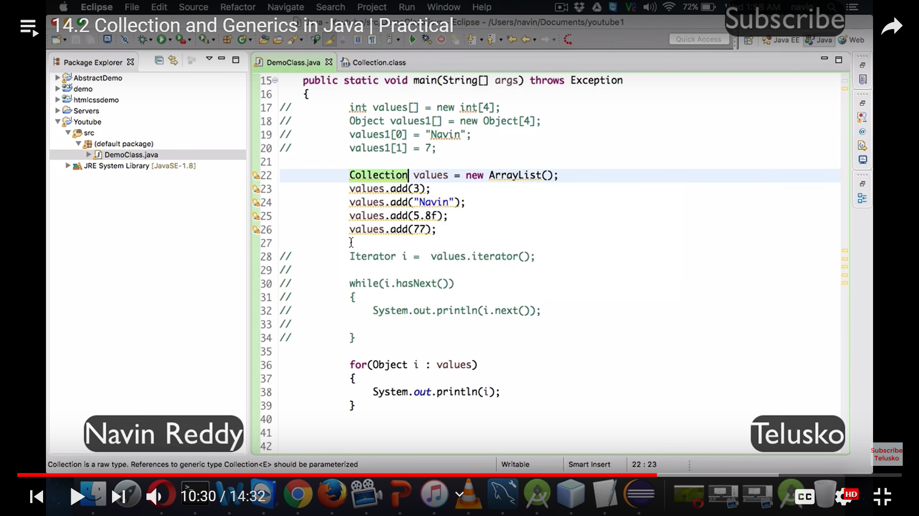

**Collections with generics**

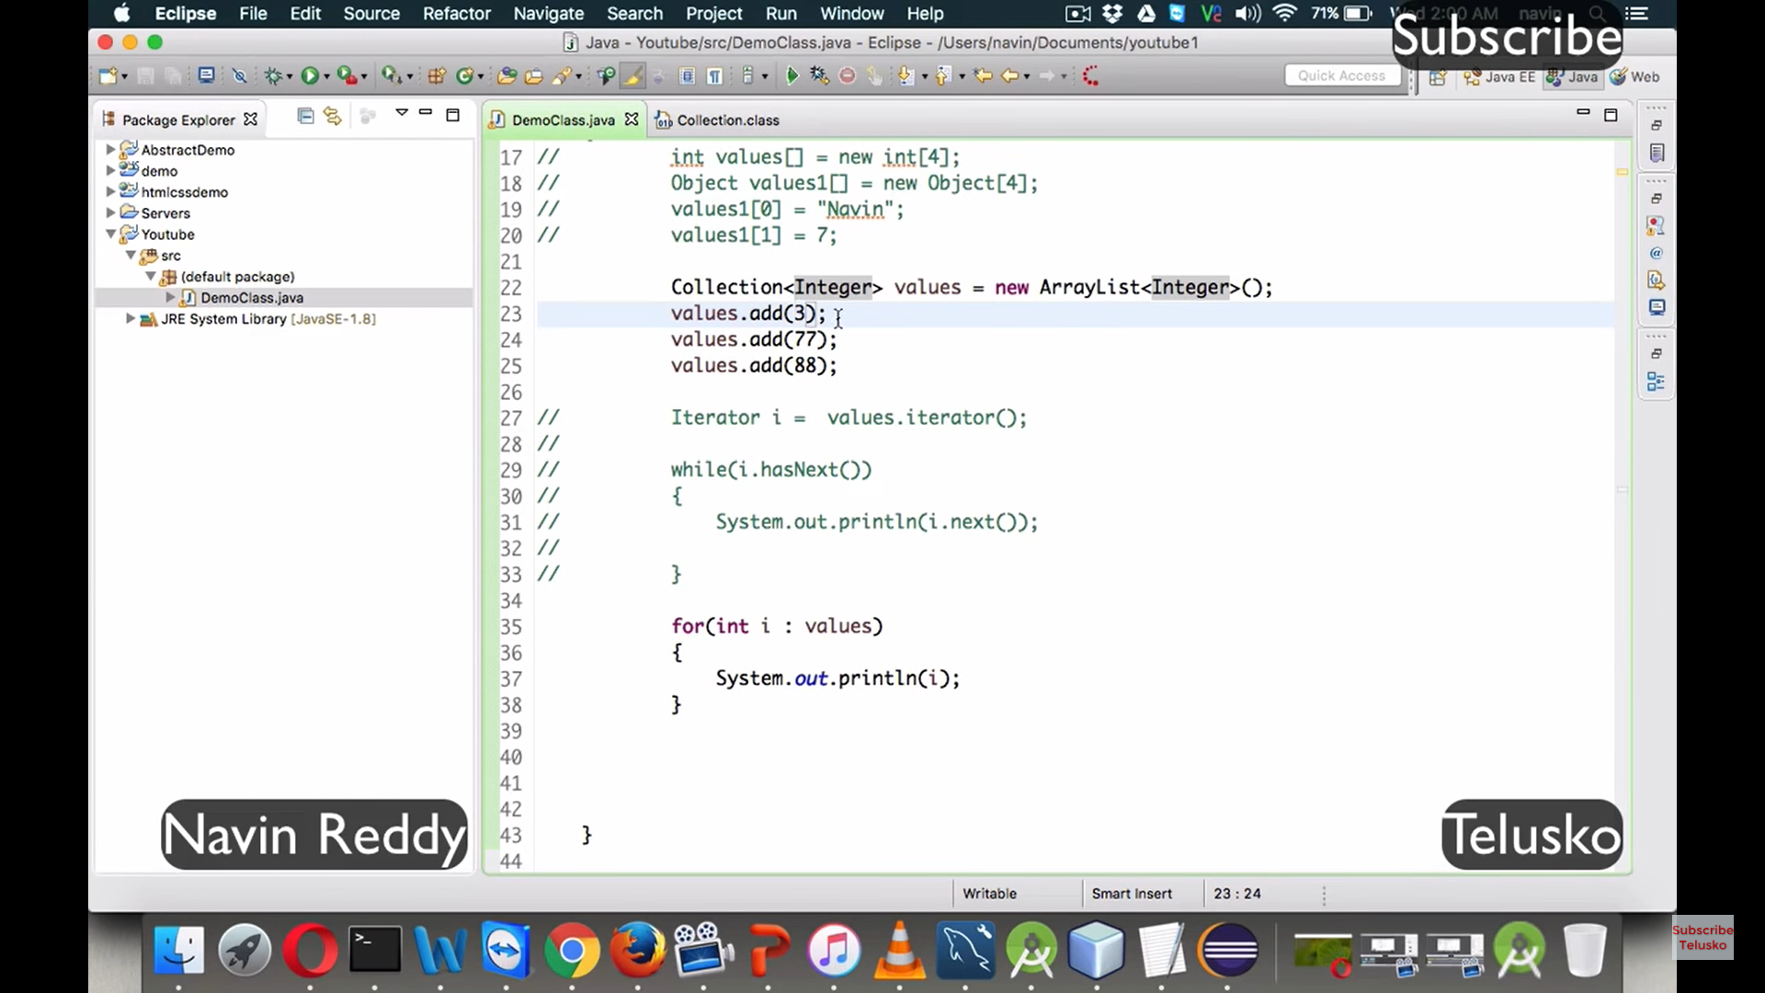

**Generics** is introduced to maintain **type safety** of a variable meaning whether the collections are about integer, string etc

List<**Integer**> country = new ArrayList<>();

**Map Interface:**

It is not part of the collection interface. Prefer when search operation is more.

1. It is implemented by the class HashMap and HashTable.
2. Insertion order is not maintained,
3. Duplicate keys are not allowed (i.e., it will allow the user to write but will replace the old declaration with the latest one) but duplicate values are allowed.
4. maintain the data in key and value pair.
5. Each key value pair is called Entry
6. Null key is allowed once but can have multiple null values (only for hashmap).

**Method allowed –**

HashMap map = new HashMap();

map.put(key,pair) 🡪 to add data

map.putAll(Mapcollection) 🡪 to add one more map

map.get(keyName) 🡪 return the value of the particular key

map.remove(keyName) 🡪 remove the particular entry / pair

map.containsKey(keyName) 🡪 returns true or false based on the key availability in map

map.containsValue(value) 🡪 returns true or false based on the value availability in map

map.isEmpty() 🡪 returns true or false based on map is empty or not

map.size() 🡪 returns how many entries in hashmap

map.clear() 🡪 clears the map

map.keySet() 🡪 returns all the keys from the hashmap. The return type is set bcoz no duplicate keys

map.values() 🡪 returns all the value from the hashmap. Return type is collection

map.entrySet() 🡪 returns all the entry set from the map. Return type is Set.

We can apply getKey(), getValue() and setValue() on entryset(). This is useful when we want to iterate through the map.

|  |  |  |
| --- | --- | --- |
| S.No. | HashMap | HashTable |
| 1 | Not thread safe | Thread safe |
| 2 | Fast | Slow |
| 3 | Allow one null key and multiple null value | No null key as well as values are allowed |
| 4 |  |  |

**Iterate a map using for each loop:**

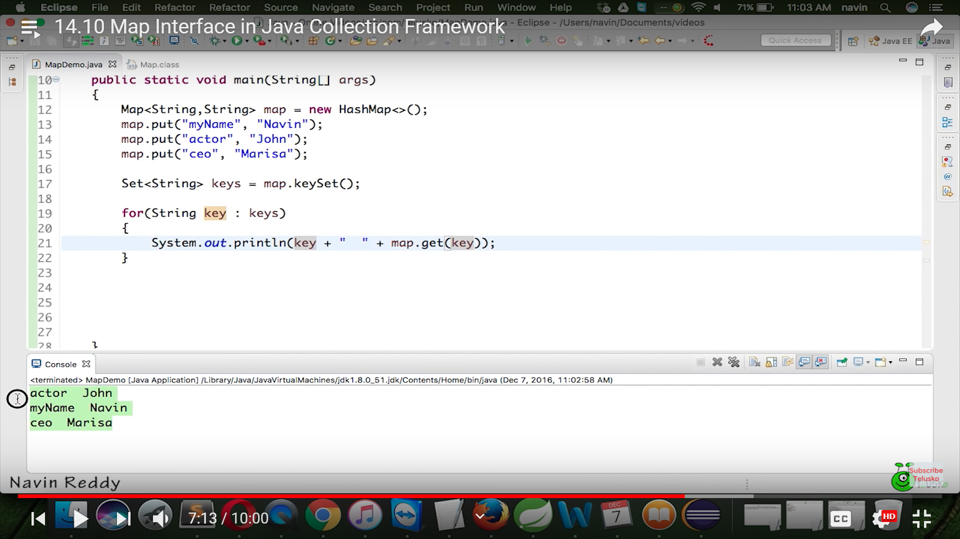

Way to iterate through hashmap

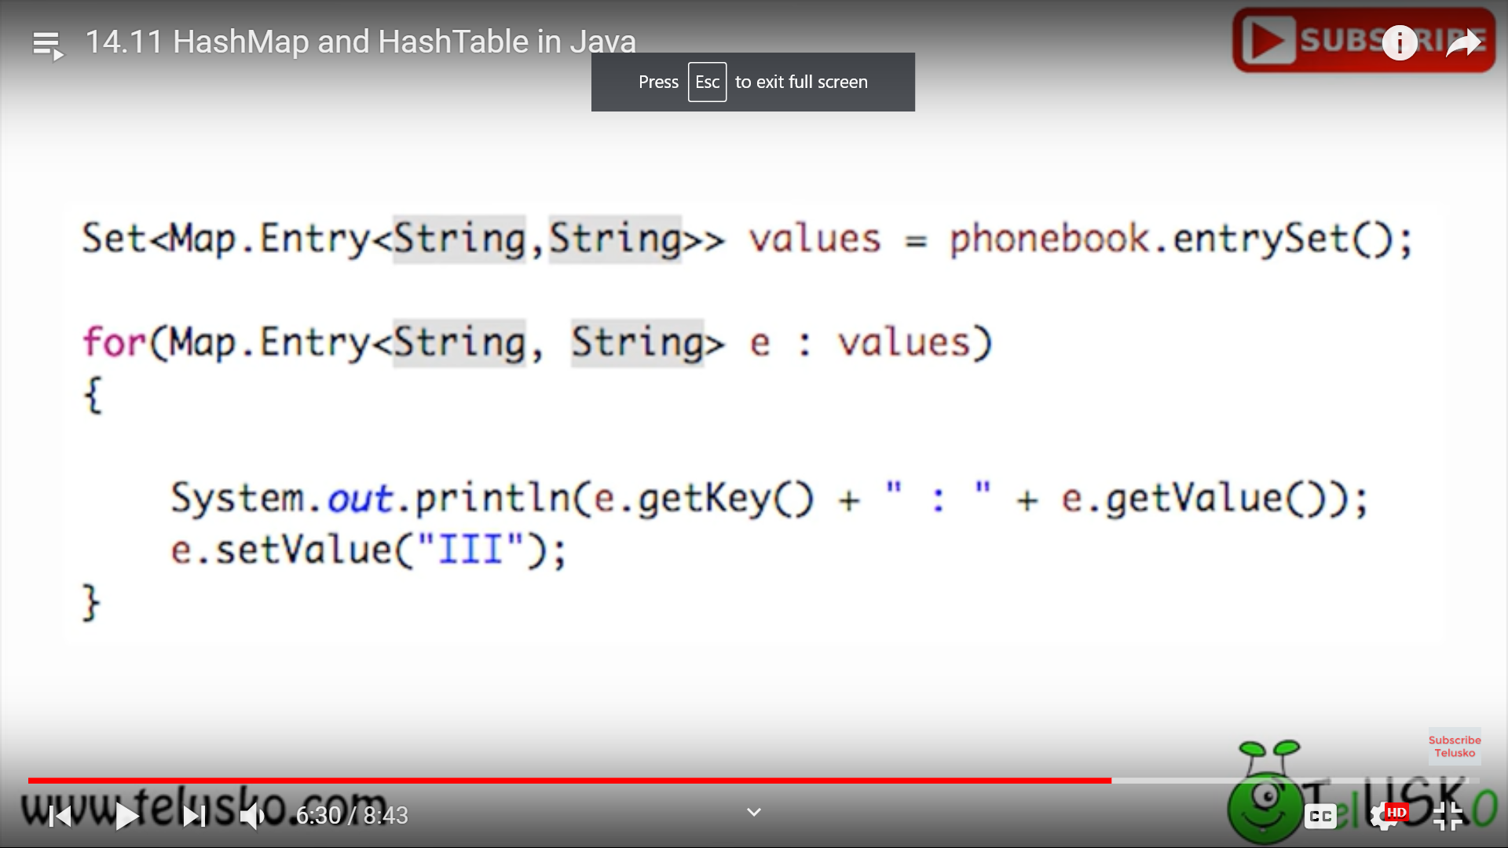

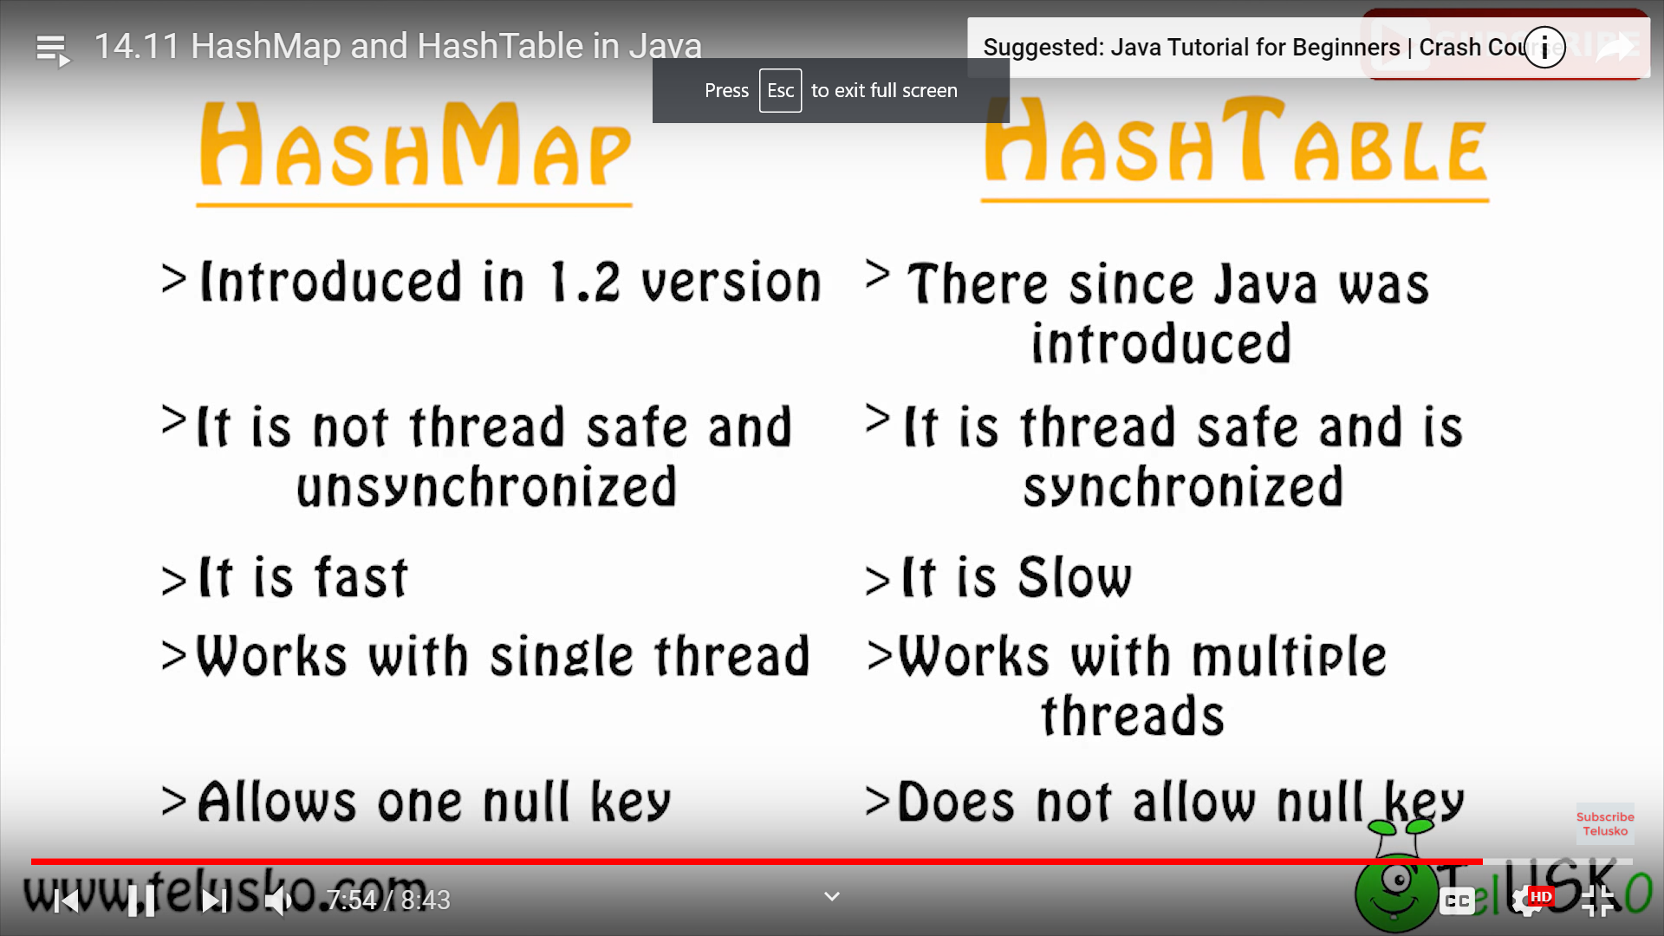

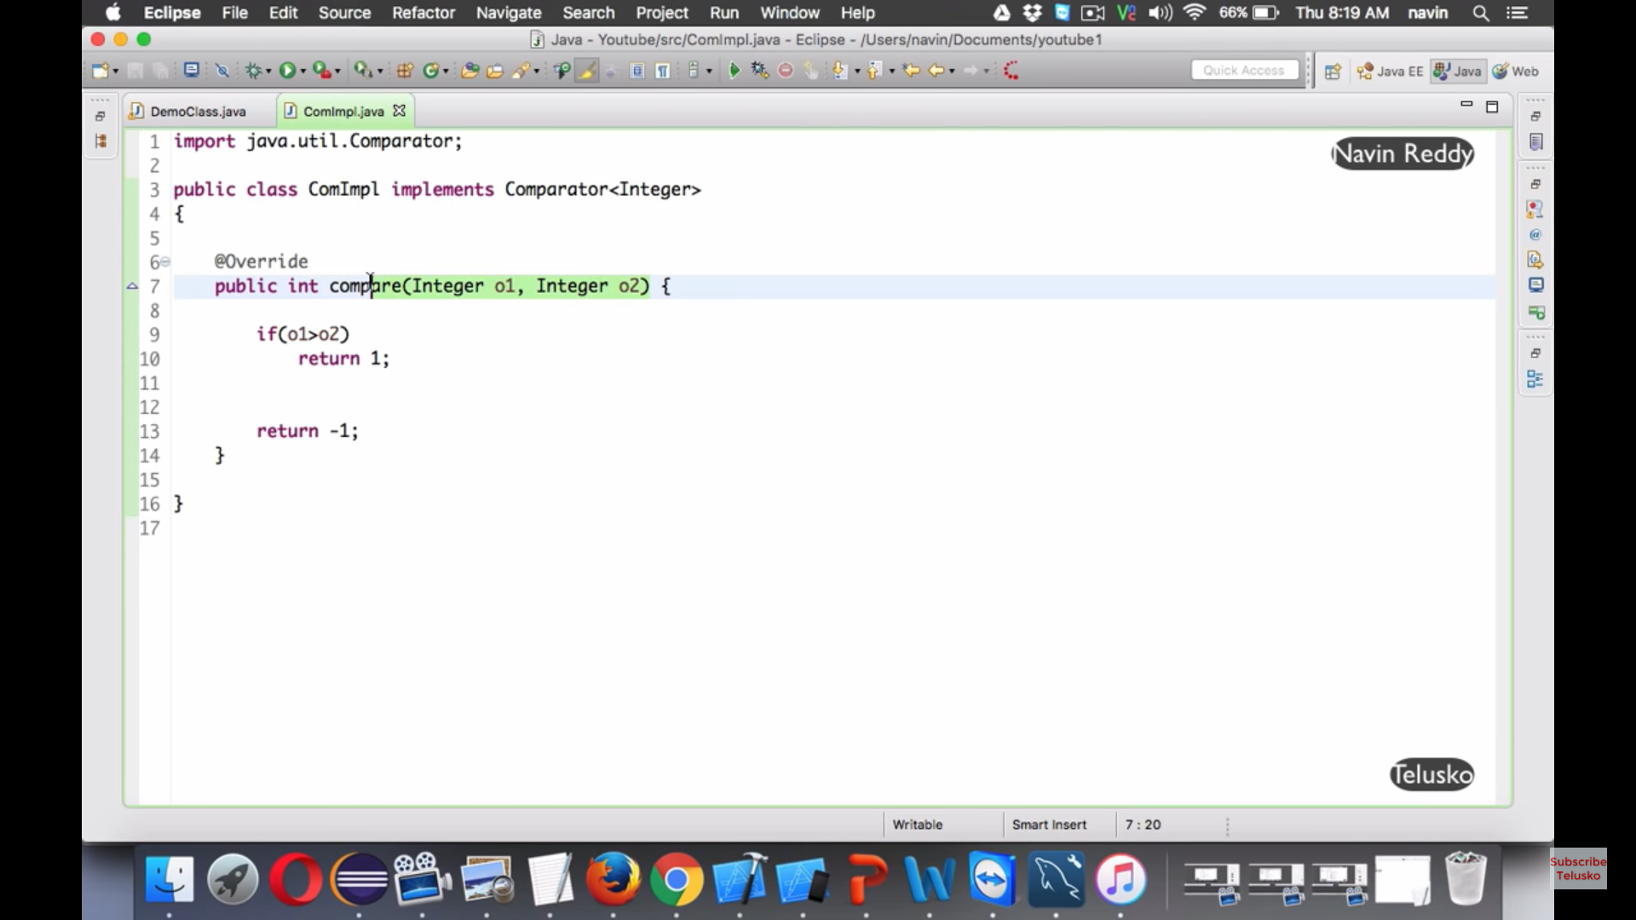

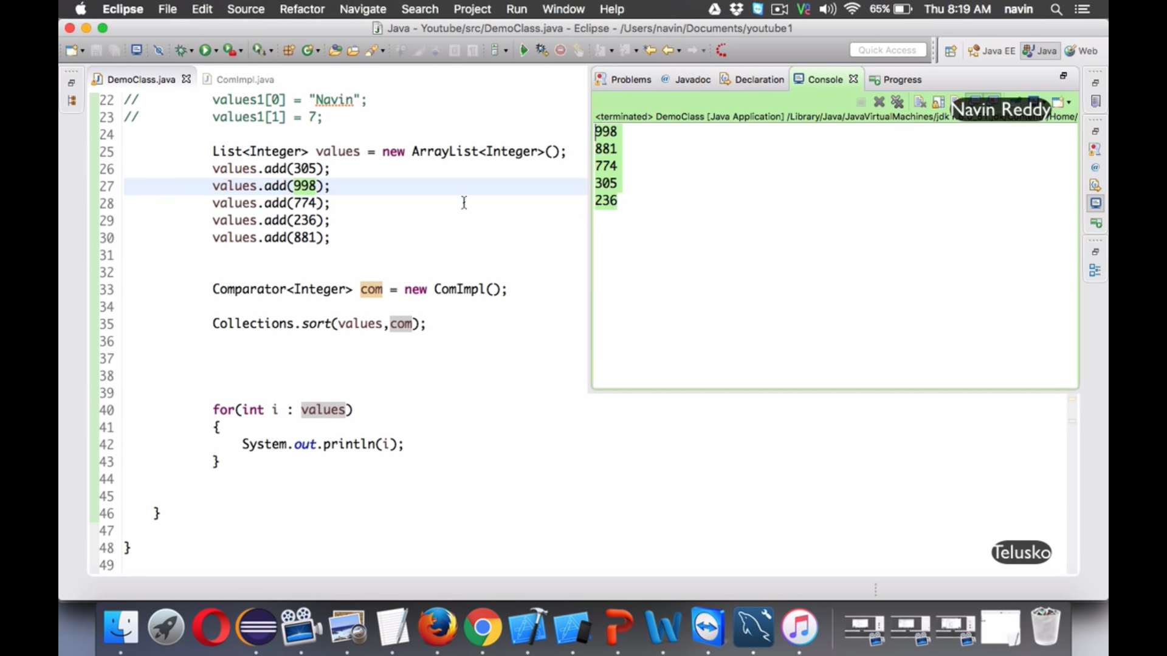

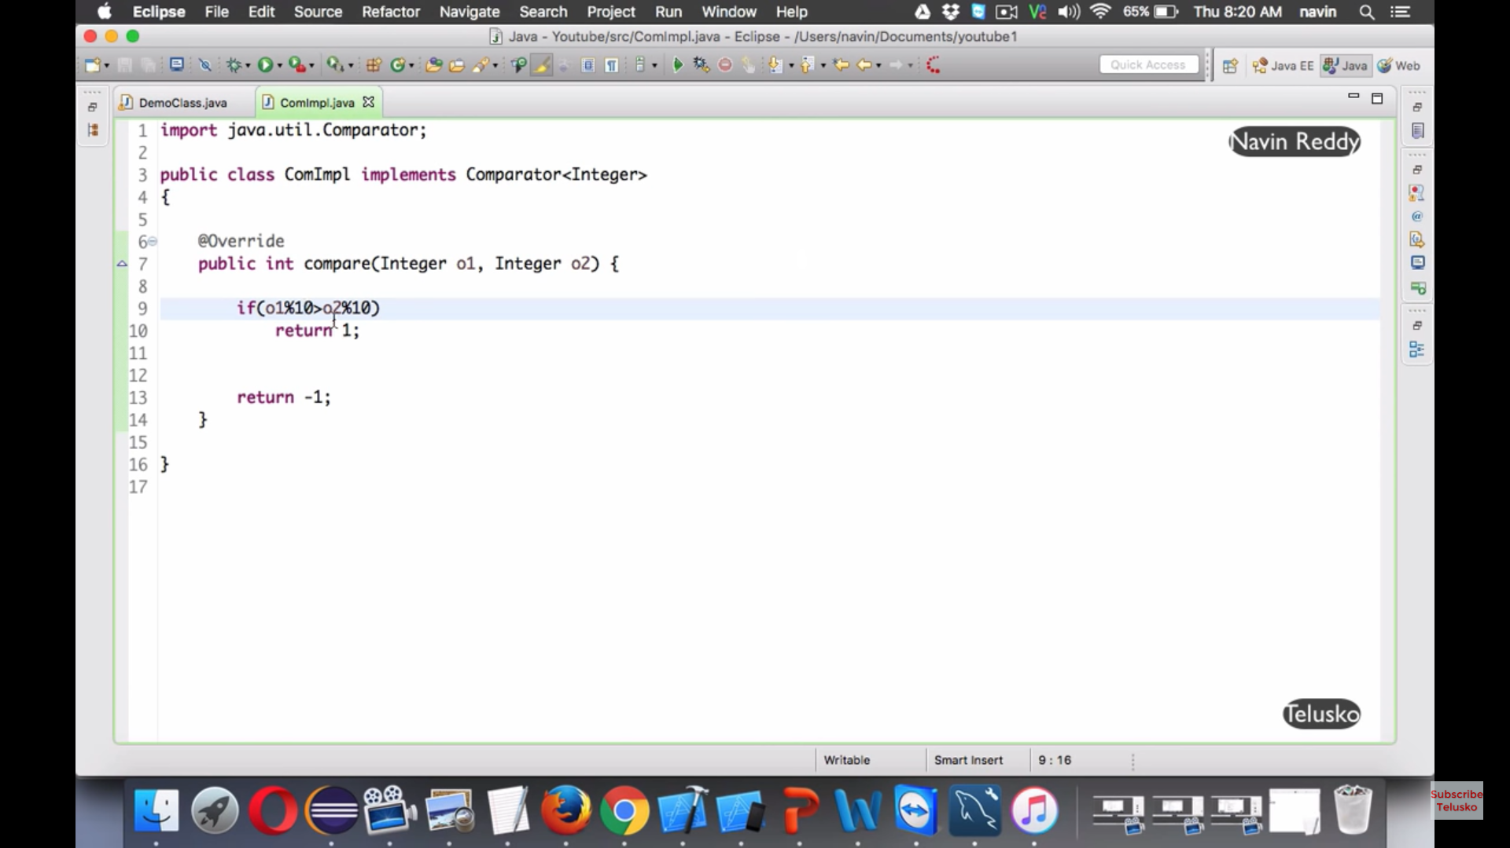

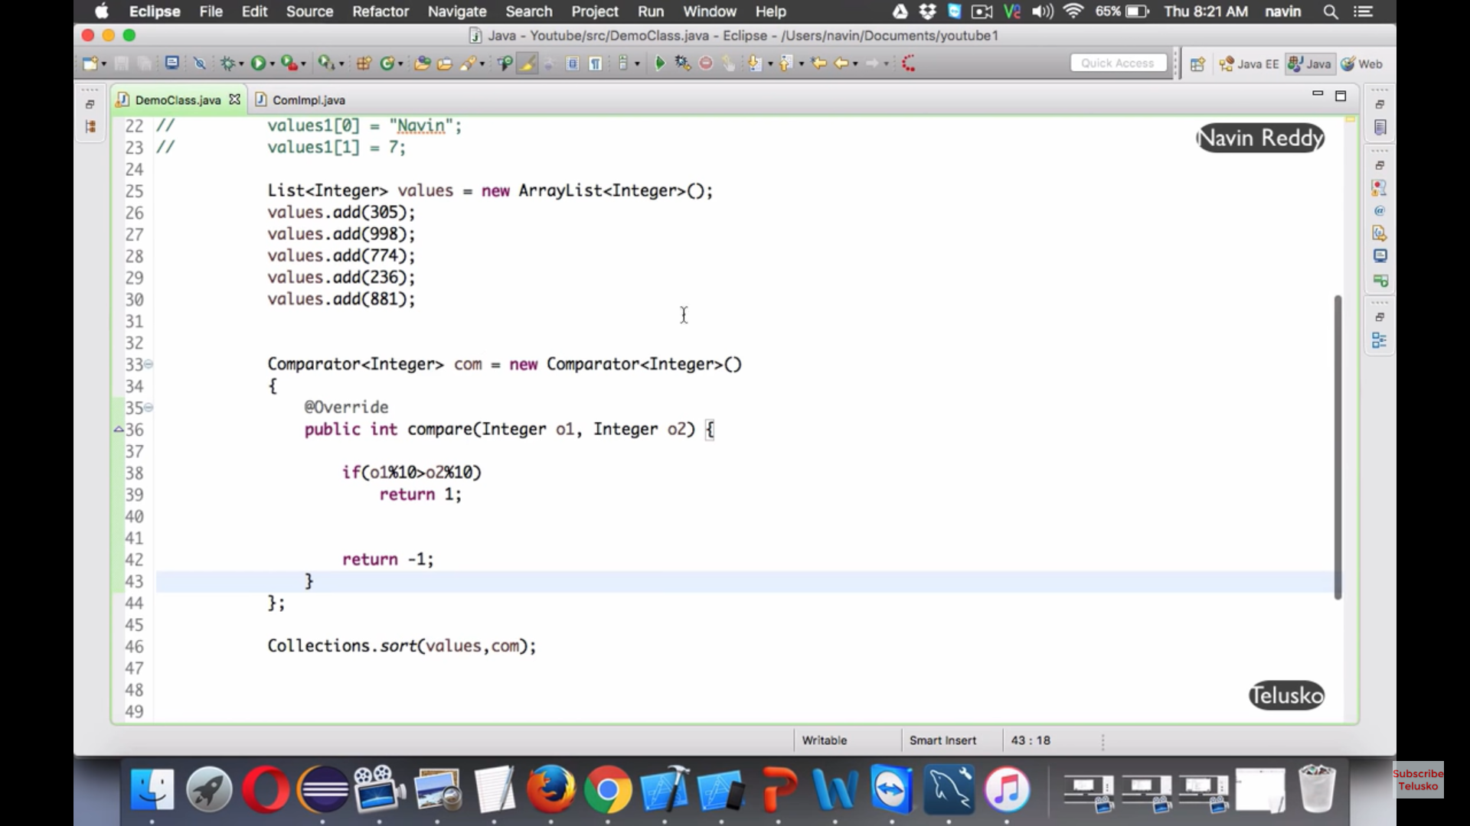

How to print the duplicate elements

